HOW TO CREATE BRAND NAME, BRAND MAIL AND BRAND LOGO IN CANVA
Our brand name generator checks the domain availability of your selected business name by pulling from major domain providers. We check to see if the social handles are available, including social handle alternatives (e.g. those with appended prefixes and suffixes).

PURPOSE
A brand name is used by a company for a specific product or service. Brand names can be similar or the same as the names of company founders. The reason why this happens is because it aims to raise consumer awareness, promote brand loyalty and Visual Identity.
A strong brand purpose makes your brand stand out in a busy market. The why behind your what clarifies your brand's offering to consumers, and taps into important emotional connections that can foster a strong sense of brand loyalty amongst your consumers.
Logos are a point of identification; they're the symbol that customers use to recognize your brand. Ideally, you'll want people to instantly connect the sight of your logo with the memory of what your company does – and, more importantly, how it makes them feel.
Most experts agree that choosing a good name is important. A name encapsulates all of the content — intellectual and emotional — that people associate with a product or service. Some names make this process of association easier than others.
Brand purpose lets buyers quickly see which companies align with their personal beliefs, helping them decide where they'd like to spend their money. Define your brand purpose, and you will reach new target audiences and be able to nurture those all-important emotional connections far more effectively.
EMPATHY MAP

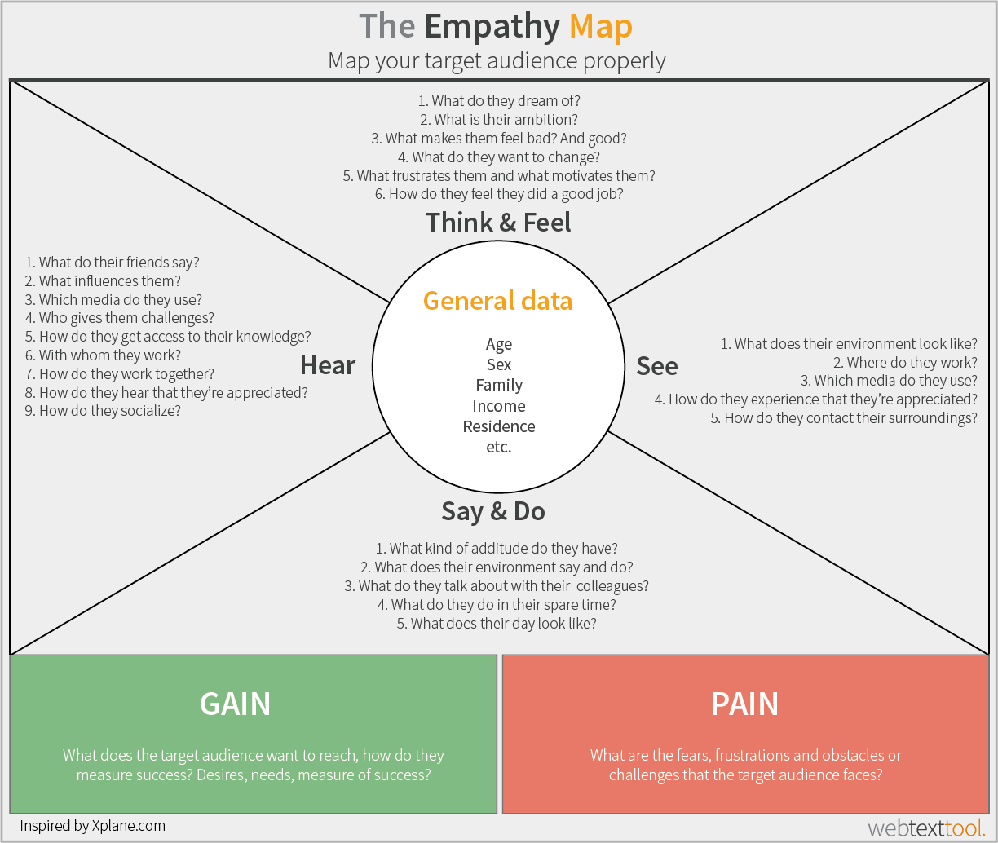

BRAIN STROM

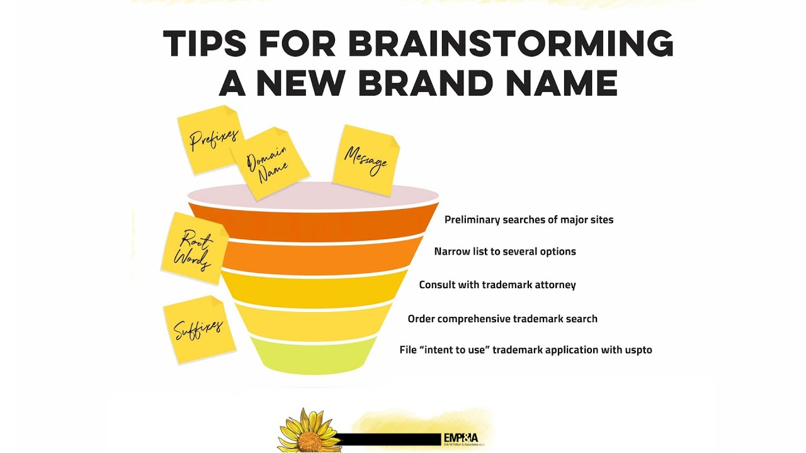

ADVANTAGES
- Increases Brand Recognition.
- Improves Customer Loyalty to Your Brand.
- Positive Word of Mouth Marketing.
- Higher Advertising Effectiveness on Customers.
- Lower Price Sensitivity.
- More Applicants That Want to Work for Your Brand.
- Engaged Employees Who Are Proud to Work at Your Company.

CONCLUSION
You don't have to be a large business to be a brand. Your brand is your identity, and how you bring it to life in a way that's compelling, coherent, and meaningful to your audience. It's the intersection of who you say you are and how your audience sees you.
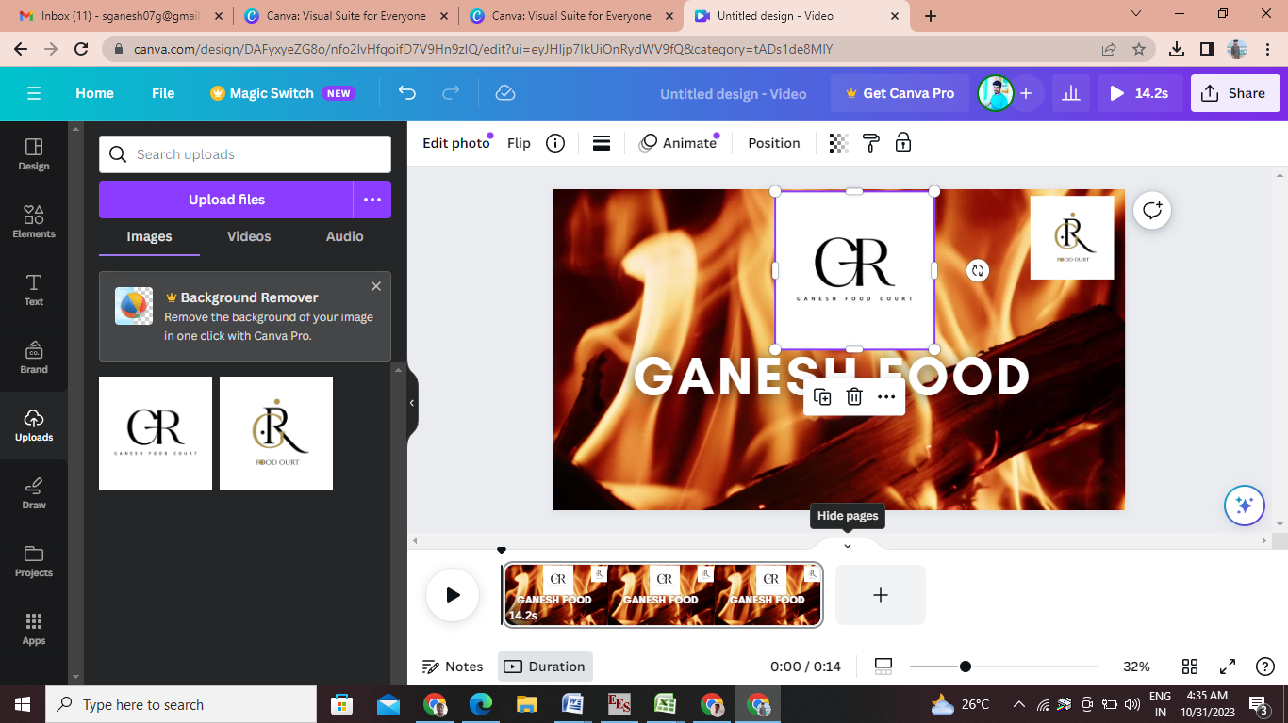

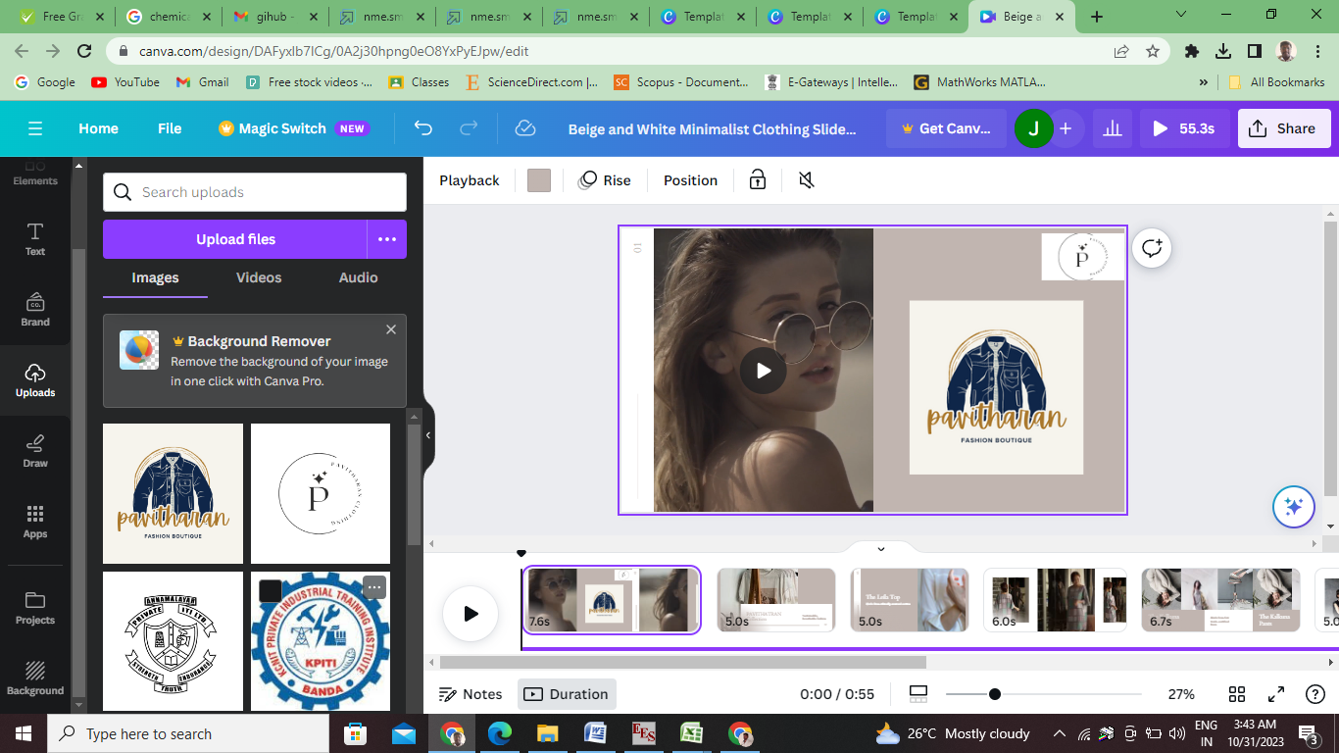

https://pavitharanclothing.blogspot.com/2023/10/clothing-video.html
https://pavitharanclothing.blogspot.com/
https://github.com/JAYAOMPRAKASH/PAVITHARAN12/tree/main

